**PYTHON TASK ONE -   
SIMPLE CALCULATOR WITH ADVANCE FEATURES**

Q.) Write a python program for simple calculator with advance features, which implements a simple calculator with advanced features such as addition, subtraction, multiplication, division, exponentiation, and the option to quit. Study the code and explain how the program works, including its main features and functionality. Additionally, Imagine you've been tasked with creating comprehensive documentation for a Python project . Your documentation should include detailed explanations of the code along with images illustrating the program's execution and user interactions.

A.)

**Code for Python Calculator :-**

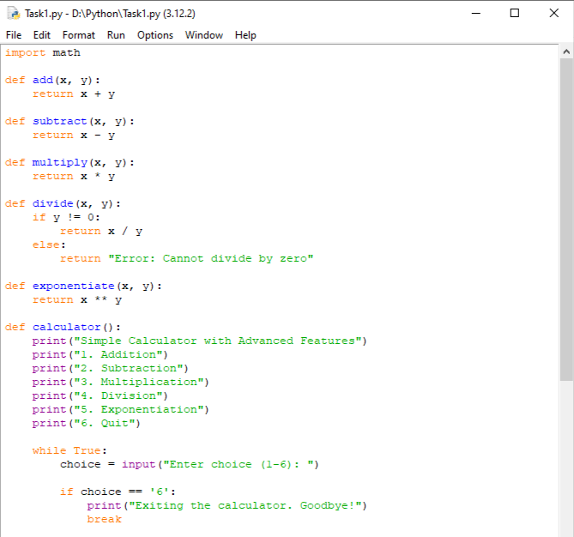

 - Ammaar Quadri

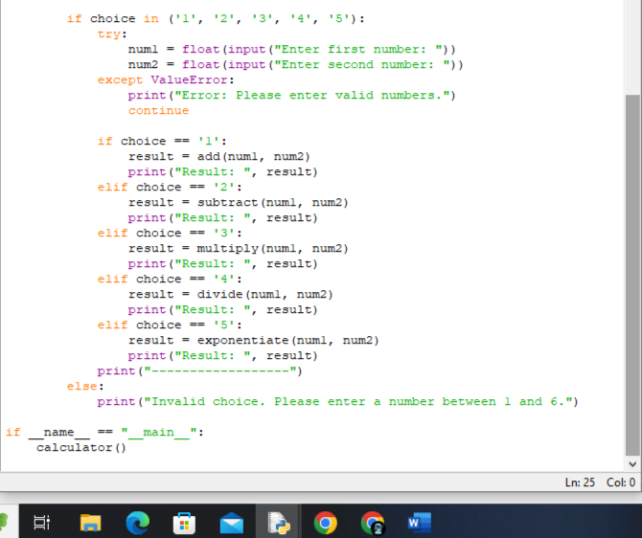

 - Ammaar Quadri

**OUTPUT:-**

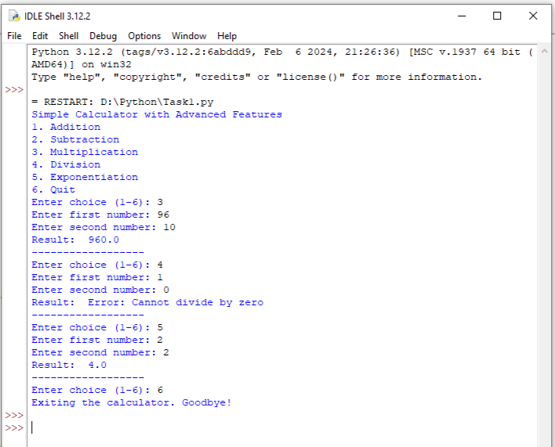

**---------- X ---------- X ---------- X ----------**  
-------------------------------------------------------------------------------------------------------------------------------------------------------------------------

 - Ammaar Quadri

**-> HOW THE PROGRAM WORKS, INCLUDING ITS MAIN FEATURES AND FUNCTIONALITY :-**

Certainly! Let's go through the code step by step to understand its features and functionality:

1. *Function Definitions:*

- The code begins with the definition of six functions: `add`, `subtract`, `multiply`, `divide`, `exponentiate`, and `calculator`.

- The first five functions (`add`, `subtract`, `multiply`, `divide`, `exponentiate`) perform basic arithmetic operations.

- The `calculator` function is the main function that controls the calculator's operation.

2. *Menu Display:*

- Inside the `calculator` function, a menu is displayed using `print()` statements. It lists the available operations (addition, subtraction, multiplication, division, exponentiation, and quit).

3. *User Input:*

- The program enters a `while` loop to continuously prompt the user for input until they choose to quit.

- Within the loop, the user is prompted to enter their choice (a number between 1 and 6) using the `input()` function.

4. *User Choices:*

- The program checks the user's choice using an `if` statement:

- If the choice is '6', the program prints a farewell message and exits the loop, effectively ending the program.

- If the choice is one of '1', '2', '3', '4', or '5', the program proceeds to perform the selected operation.

5. *Number Input and Calculation:*

- If the user's choice corresponds to an arithmetic operation, the program prompts the user to enter two numbers using `input()`.

- The entered numbers are converted to floats using `float()` to allow for decimal input.

- The program then calls the appropriate function (`add`, `subtract`, `multiply`, `divide`, or `exponentiate`) with the user's numbers as arguments.

- The result is printed to the console.

6. *Error Handling:*

- The code includes a `try-except` block to handle potential `ValueError` exceptions that may occur if the user enters non-numeric input when prompted for numbers.

7. *Invalid Choices:*

- If the user enters a choice other than '1' through '6', the program informs them of the invalid choice and prompts for input again.

8. *Main Execution:*

- The `if __name__ == "__main__":` block ensures that the `calculator` function is executed when the script is run.

 - Ammaar Quadri

**Python Calculator Documentation**

**Introduction:-**

Welcome to the comprehensive documentation for the Python Calculator project. This documentation aims to provide a detailed explanation of the code, its functionality, and user interactions. The Python Calculator is a simple yet versatile calculator program implemented in Python. It supports basic arithmetic operations such as addition, subtraction, multiplication, and division, along with advanced features like exponentiation. Users can interact with the calculator through a command-line interface, making it accessible and easy to use.

 - Ammaar Quadri

**Features:-**

- Supports addition, subtraction, multiplication, division, and exponentiation.

- Provides a user-friendly command-line interface for interaction.

- Handles invalid inputs gracefully with appropriate error messages.

- Allows users to quit the program at any time.

**Getting Started:-**

To use the Python Calculator, follow these steps:

1. Download the Code: Obtain the Python script containing the calculator code.

2. Run the Script: Execute the Python script using a Python interpreter.

3. Follow On-Screen Instructions: Interact with the calculator by following the on-screen menu.

**Code Explanation:-**

Below is a detailed explanation of the code structure and functionality:

**------------------------------------------------------------------------------------------------**

**# Importing the math module for exponentiation**

**import math**

**# Function Definitions for Arithmetic Operations**

**def add(x, y):**

**return x + y**

**def subtract(x, y):**

**return x - y**

**def multiply(x, y):**

**return x * y**

**def divide(x, y):**

**if y != 0:**

**return x / y**

**else:**

**return "Error: Cannot divide by zero"**

**def exponentiate(x, y):**

**return x ** y**

**# Main Calculator Function**

**def calculator():**

**# Display Menu Options**

**print("Simple Calculator with Advanced Features")**

**print("1. Addition")**

**print("2. Subtraction")**

**print("3. Multiplication")**

**print("4. Division")**

**print("5. Exponentiation")**

**print("6. Quit")**

**# User Interaction Loop**

**while True:**

**choice = input("Enter choice (1-6): ")**

**# Quit Option**

**if choice == '6':**

**print("Exiting the calculator. Goodbye!")**

**break**

**# Arithmetic Operations**

**if choice in ('1', '2', '3', '4', '5'):**

**try:**

**num1 = float(input("Enter first number: "))**

**num2 = float(input("Enter second number: "))**

**except ValueError:**

**print("Error: Please enter valid numbers.")**

**continue**

**if choice == '1':**

**result = add(num1, num2)**

**print("Result: ", result)**

**elif choice == '2':**

**result = subtract(num1, num2)**

**print("Result: ", result)**

**elif choice == '3':**

**result = multiply(num1, num2)**

**print("Result: ", result)**

**elif choice == '4':**

**result = divide(num1, num2)**

**print("Result: ", result)**

**elif choice == '5':**

**result = exponentiate(num1, num2)**

**print("Result: ", result)**

**else:**

**print("Invalid choice. Please enter a number between 1 and 6.")**

**# Entry Point for Execution**

**if __name__ == "__main__":**

**calculator()**

**```**

**------------------------------------------------------------------------------------------------**

 - Ammaar Quadri

**User Interactions:-**

The Python Calculator provides an interactive command-line interface for users to perform calculations. Below are images illustrating the program's execution and user interactions:

**1. Starting the Calculator:-**

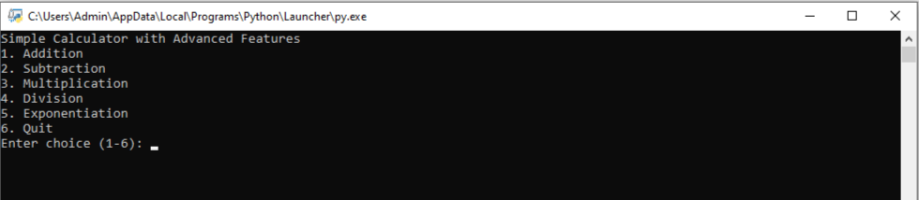

**(start_calculator.png)**

**2. Performing Addition:-**

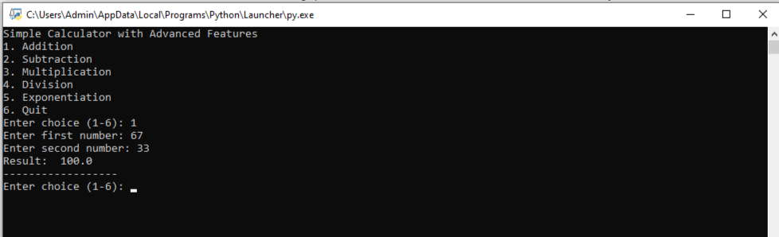

**(addition.png)**

**3. Performing Exponentiation:-**

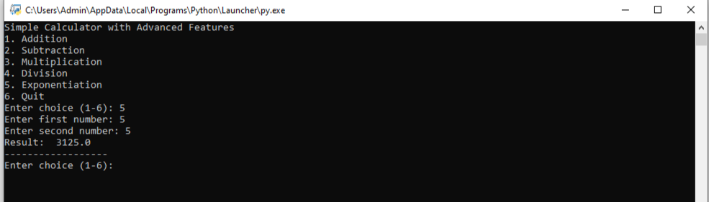

**(exponentiation.png)**

**4. Exiting the Calculator:-**

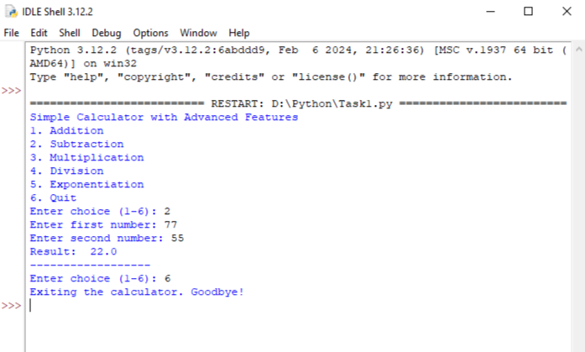

**(exit_calculator.png)**

**Conclusion:-**

This documentation has provided a comprehensive overview of the Python Calculator project, including its features, code explanation, and user interactions. With its simple yet powerful functionality, the Python Calculator serves as a useful tool for performing various arithmetic operations.

**-DONE BY:-**

**Muhammad Ammaar Quadri**

 - Ammaar Quadri